**Business Case: SQL**

1. Import the dataset and do usual exploratory analysis steps like checking the structure & characteristics of the dataset
   1. Data type of columns in a table
   2. Time period for which the data is given
   3. Cities and States covered in the dataset

Solution :

* + - * Data type of columns in a table

SELECT column_name, data_type

FROM `<CompanySchema>.INFORMATION_SCHEMA.COLUMNS`

WHERE table_name="customers";

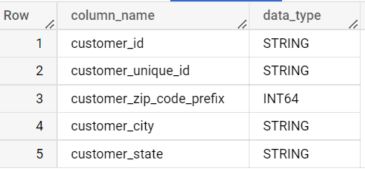

SELECT column_name, data_type

FROM `<CompanySchema>.INFORMATION_SCHEMA.COLUMNS`

WHERE table_name="orders";

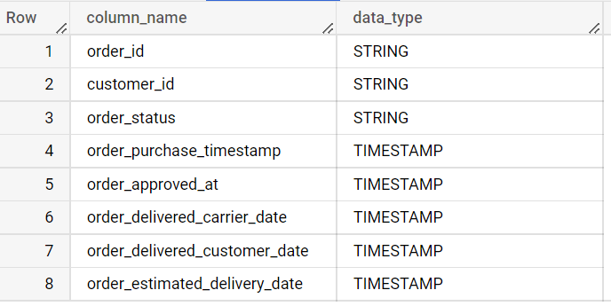

* + - * Time period for which the data is given

select distinct EXTRACT(YEAR from order_purchase_timestamp) YEAR,

EXTRACT(MONTH from order_purchase_timestamp) MONTH

from <CompanySchema>.orders

order by YEAR,MONTH;

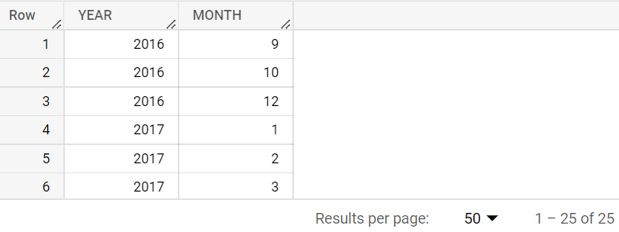

** Data Time Period : Sept,2016 to Oct,2018

* + - * Cities and States covered in the dataset

select distinct geolocation_state,geolocation_city from <CompanySchema>.geolocation

order by geolocation_state;

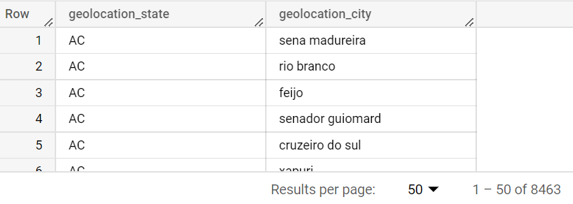

select distinct geolocation_state,

count(geolocation_city) as city_count from <CompanySchema>.geolocation

group by geolocation_state

order by geolocation_state;

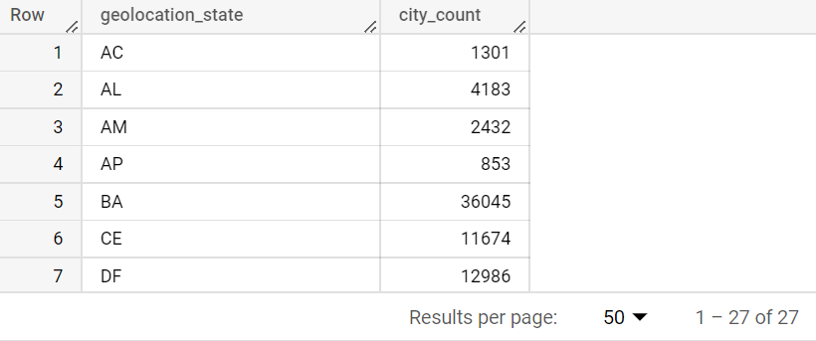

1. In-depth Exploration:
   1. Is there a growing trend on e-commerce in Brazil? How can we describe a complete scenario? Can we see some seasonality with peaks at specific months?
   2. What time do Brazilian customers tend to buy (Dawn, Morning, Afternoon or Night)?

Solution :

* + - * Is there a growing trend on e-commerce in Brazil? How can we describe a complete scenario? Can we see some seasonality with peaks at specific months?

select *,

No_of_Order-LAG(No_of_Order,1) over(partition by ORDER_YEAR order by ORDER_MONTH asc) as growth_over_year,

dense_rank() over(partition by ORDER_YEAR order by No_of_Order desc) as rank_orderValue,

from

(select ORDER_YEAR,ORDER_MONTH,count(order_id) No_of_Order from

(select distinct order_id,EXTRACT(YEAR  from order_purchase_timestamp) as ORDER_YEAR,

EXTRACT(MONTH  from order_purchase_timestamp) AS ORDER_MONTH

from <CompanySchema>.orders) t

group by ORDER_YEAR,ORDER_MONTH

ORDER BY ORDER_YEAR,ORDER_MONTH) t2

ORDER BY ORDER_YEAR,ORDER_MONTH;

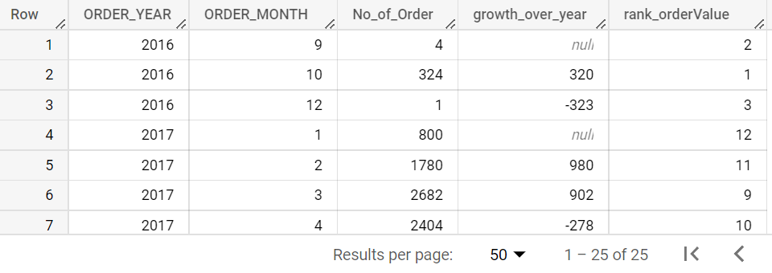

** No. of orders is surely increasing over months with some exceptional dips for few months in between. Positive growth_over_year shows No. of Orders getting increased over month.

Checking the rank of No. of orders for each month gives us an idea that order has been on peak around September to November month every year, though for 2018 it’s not the same because it looks like data is not complete for 2018 end of the month in this dataset.

* + - * What time do Brazilian customers tend to buy (Dawn, Morning, Afternoon or Night)?

select * from

(select EXTRACT(HOUR  from order_purchase_timestamp) as ORDER_HOUR,

count(distinct order_id) as No_of_Orders

from <CompanySchema>.orders

group by EXTRACT(HOUR  from order_purchase_timestamp))

order by No_of_Orders desc;

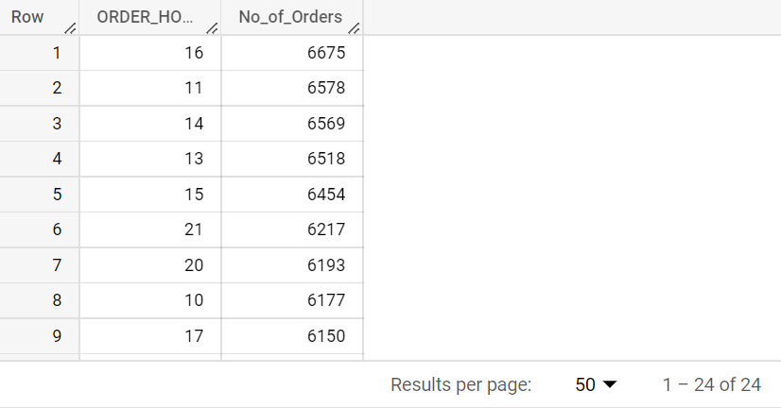

** No. of Orders is highest at around 16:00 hour which is Afternoon time, however, No. of orders pick up at around 10 in the morning and till 22:00 – 23:00 hour the volume of order is high.

1. Evolution of E-commerce orders in the Brazil region:
   1. Get month on month orders by region, states
   2. How are customers distributed in Brazil

Solution :

* + - * Get month on month orders by region, states

select distinct customer_state, customer_city, ORDER_YEAR, ORDER_MONTH,

count(distinct order_id) over(partition by customer_state, customer_city, ORDER_YEAR,ORDER_MONTH) No_of_Orders FROM

(select c.customer_state, c.customer_city, order_id, EXTRACT(YEAR  from order_purchase_timestamp) as ORDER_YEAR,

EXTRACT(MONTH  from order_purchase_timestamp) AS ORDER_MONTH

from <CompanySchema>.customers c

left join <CompanySchema>.orders o

on c.customer_id=o.customer_id)

order by customer_state,ORDER_YEAR,ORDER_MONTH,customer_city;

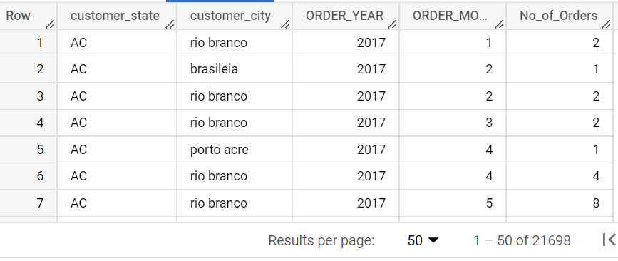

* + - * How are customers distributed in Brazil

select customer_state,customer_city,

count(distinct customer_id) No_of_Customers

from <CompanySchema>.customers

group by customer_state,customer_city

order by customer_state,No_of_Customers desc;

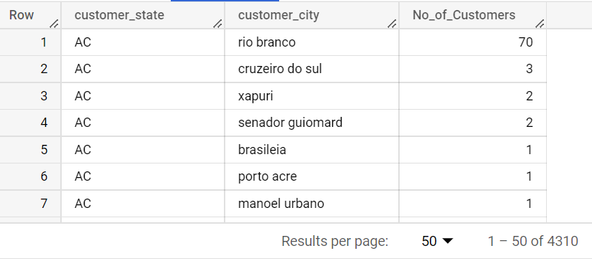

1. Impact on Economy: Analyze the money movemented by e-commerce by looking at order prices, freight and others.
   1. Get % increase in cost of orders from 2017 to 2018 (include months between Jan to Aug only)
   2. Mean & Sum of price and freight value by customer state

Solution :

* + - * Get % increase in cost of orders from 2017 to 2018 (include months between Jan to Aug only)

select ORDER_YEAR, sum(Order_cost) OrderCostSum_overYear,

(sum(Order_cost)-LAG(sum(Order_cost)) over(order by sum(Order_cost)))*100/LAG(sum(Order_cost)) over(order by sum(Order_cost)) PercentValue_diff

from

(select distinct order_id, EXTRACT(YEAR from shipping_limit_date) ORDER_YEAR, price as Order_cost

from <CompanySchema>.order_items

where EXTRACT(MONTH from shipping_limit_date) between 1 and 8

and EXTRACT(YEAR from shipping_limit_date) in (2017,2018))

group by ORDER_YEAR

order by ORDER_YEAR;

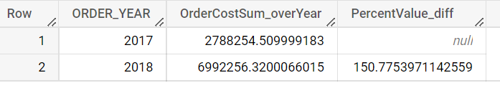

** For the months between Jan to July, % increase in sum of cost of orders from 2017 to 2018 is around 150%.

* + - * Mean & Sum of price and freight value by customer state

select customer_state,sum(price+freight_value) sum_CostValue,

avg(price+freight_value) mean_CostValue from

(select distinct customer_state,oi.order_id,price,freight_value from

<CompanySchema>.customers c inner join <CompanySchema>.orders o

on c.customer_id=o.customer_id

inner join <CompanySchema>.order_items oi

on o.order_id=oi.order_id)

group by customer_state

order by customer_state;

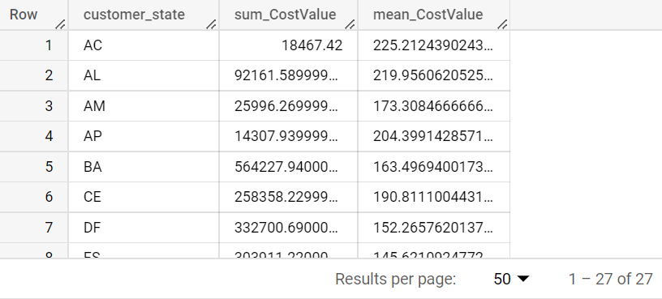

** For different customer states, sum and mean value for Cost (Price + Freight value) is calculated as above.

1. Analysis on sales, freight and delivery time
   1. Calculate days between purchasing, delivering and estimated delivery
   2. Create columns:
      * time_to_delivery = order_purchase_timestamp-order_delivered_customer_date
      * diff_estimated_delivery = order_estimated_delivery_date-order_delivered_customer_date
   3. Group data by state, take mean of freight_value, time_to_delivery, diff_estimated_delivery
   4. Sort the data to get the following:
      * 1. Top 5 states with highest/lowest average freight value - sort in desc/asc limit 5
        2. Top 5 states with highest/lowest average time to delivery
        3. Top 5 states where delivery is really fast/ not so fast compared to estimated date

Solution :

* + - * Top 5 states with highest/lowest average freight value - sort in desc/asc limit 5

select customer_state, avg(time_to_delivery) mean_time_to_delivery,

avg(diff_estimated_delivery) mean_diff_estimated_delivery, avg(freight_value) mean_freight_value from

(select distinct t.*,freight_value from

(select distinct customer_state,o.order_id,order_purchase_timestamp,order_estimated_delivery_date,order_delivered_customer_date,

TIMESTAMP_DIFF(order_delivered_customer_date,order_purchase_timestamp,DAY) time_to_delivery,

TIMESTAMP_DIFF(order_estimated_delivery_date,order_delivered_customer_date,DAY) diff_estimated_delivery

from <CompanySchema>.orders o

join <CompanySchema>.customers c

on o.customer_id=c.customer_id) t

join <CompanySchema>.order_items oi

on t.order_id=oi.order_id)

group by customer_state

order by mean_freight_value

limit 5;

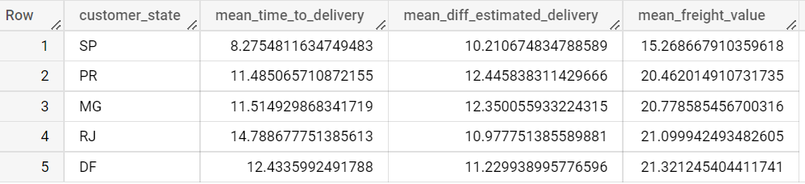

** Mean time to delivery is calculated as average of ‘order delivered to customer’ date minus ‘order purchase date’ over different customer state.

Mean difference of estimated delivery is calculated as average of ‘order estimated delivery date’ minus ‘order delivered customer date’ over different customer state.

Also, Mean Freight value is calculated over each customer state and is ordered by the same in ascending and data limited to count 5.

* + - * Top 5 states with highest/lowest average time to delivery

select customer_state, avg(time_to_delivery) mean_time_to_delivery,

avg(diff_estimated_delivery) mean_diff_estimated_delivery,avg(freight_value) mean_freight_value from

(select distinct t.*,freight_value from

(select distinct customer_state,o.order_id,order_purchase_timestamp,order_estimated_delivery_date,order_delivered_customer_date,

TIMESTAMP_DIFF(order_delivered_customer_date,order_purchase_timestamp,DAY) time_to_delivery,

TIMESTAMP_DIFF(order_estimated_delivery_date,order_delivered_customer_date,DAY) diff_estimated_delivery

from <CompanySchema>.orders o

join <CompanySchema>.customers c

on o.customer_id=c.customer_id) t

join <CompanySchema>.order_items oi

on t.order_id=oi.order_id)

group by customer_state

order by mean_time_to_delivery desc

limit 5;

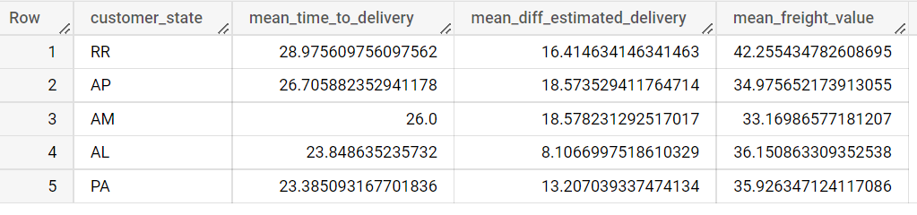

* + - * Top 5 states where delivery is really fast/ not so fast compared to estimated date

select customer_state, avg(time_to_delivery) mean_time_to_delivery,

avg(diff_estimated_delivery) mean_diff_estimated_delivery,

avg(freight_value) mean_freight_value from

(select distinct t.*,freight_value from

(select distinct customer_state,o.order_id,order_purchase_timestamp,order_estimated_delivery_date,order_delivered_customer_date,

TIMESTAMP_DIFF(order_delivered_customer_date,order_purchase_timestamp,DAY) time_to_delivery,

TIMESTAMP_DIFF(order_estimated_delivery_date,order_delivered_customer_date,DAY) diff_estimated_delivery

from <CompanySchema>.orders o

join <CompanySchema>.customers c

on o.customer_id=c.customer_id) t

join <CompanySchema>.order_items oi

on t.order_id=oi.order_id)

group by customer_state

order by mean_diff_estimated_delivery

limit 5;

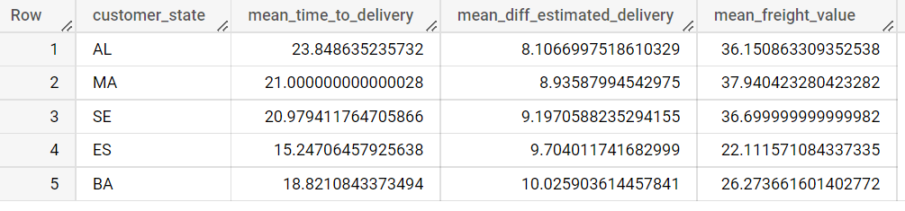

** AL customer state has least mean difference of delivered order from estimated order.

1. Payment type analysis:
   1. Month over Month count of orders for different payment types
   2. Distribution of payment installments and count of orders

Solution :

* + - * Month over Month count of orders for different payment types

select Order_Year,Order_Month,payment_type,count(order_id) count_orders from

(select distinct

EXTRACT(YEAR from order_purchase_timestamp) Order_Year,EXTRACT(MONTH from order_purchase_timestamp) Order_Month,payment_type,o.order_id

from <CompanySchema>.orders o

inner join <CompanySchema>.payments p

on o.order_id=p.order_id)

group by Order_Year,Order_Month,payment_type

order by Order_Year,Order_Month;

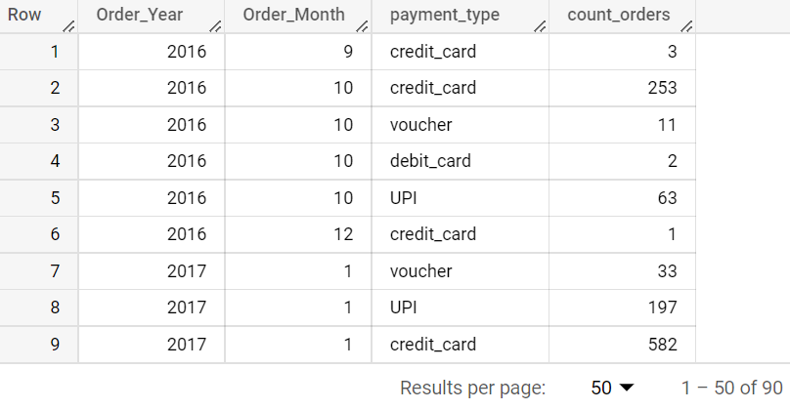

** From above analysis, we can see that for different payment type over different month of 2016 year and onwards, the count of orders are varying.

* + - * Distribution of payment installments and count of orders

select payment_installments, count(order_id) count_orders

from <CompanySchema>.payments

group by payment_installments

order by payment_installments;

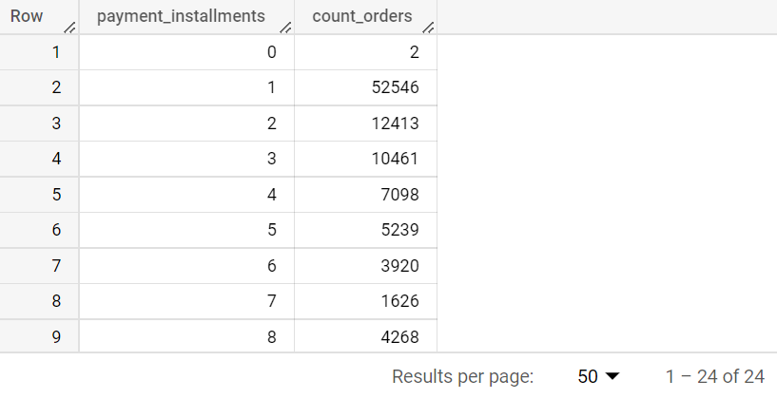

** Count of orders calculation for different payment installments.

1. Actionable Insights
   * + - As we can see that more orders are placed at around 16:00 hour afternoon, so we need to make sure products are available in plenty and should not go out of stock
       - Focus on states where time of delivery is more to bring down the No. of days to be taken to deliver the product
       - Increase delivery frequency/agents to bring down estimated time of delivery for orders
       - For the states, where average freight value is more, we need to further break down the cost to be bear by customers and bring it down
       - Based on the review score, improve the service and quality of products and delivery experience for customers
2. Recommendations
   * + - Around September to November of every year, the customer engagement is more, so we can provide benefits like discounts, vouchers, offers, etc to retain the customers and attract more customers
       - Credit card seems to be used of more often as payment mode, so we can come up with good offers on credit card payments.
       - Also, we can collaborate with more credit card banks for allow payments for customers
       - Looking at number of customers for different cities each state, we can see the engagement and focus on bringing more customers for other cities
       - Looking into count of sellers per city for different states, we can bring in more sellers to better meet demand-supply

***** End of Document *****